Fourth Status Report



4/13/06

Group Members:

Jason Abbett
Devon Berry

Accomplishments

We have accomplished a great deal since the last status report. First we have changed the way that the robot navigates the course. Instead of following the lines at the intersection, it will travel to the middle of the intersection and perform a 90 degree turn. Then all it has to do is follow the lines straight everywhere it goes. This makes the robot much more reliable. Its chances of completing the course improve greatly. Also to improve the likelihood of the robot completing the course, we added some code for when the robot loses the line and becomes lost. When this happens the robot will use the last place that it had the line at and try to find the line again. We set up a 100 ms delay before this code begins, so it does not think it is lost to quickly if it really isn't. With the two additions the chance of the robot completing the entire course is in the 90% percentile range. On top of that we added code to scan for the can when the robot enters a room. The robot will do a sweep with the sonar and if it finds a can, it will use the cans as bounds for the sonar. Then the robot will center on the can and take a sampling rate with the camera. This works very well but is slow. The robot has to be very precise in order to pick up the can with the claw. It must be the right distance and position or the claw will not pick up the can. April 8th was the day of the competition. We had two decent runs and ended up placing 9th out of the 37 teams that participated. That places us in the upper 25% percentile range. All of the code worked great and the robot did what we expected it to do. The only problem was time. Our robot was just not fast enough at attempting the course.

Obstacles
We have had to endure many obstacles over the duration of the senior project. The most recent obstacle we have had to face is trying to add a touch sensor at the last minute. A week before the competition we thought it might be a good idea to add a touch sensor to the claw. This way the robot would know if it had missed a can or not. We wired and coded the touch sensor and had it working properly. The problem was, we had to place on the claw behind the foam padding used to grip a can. When it was placed behind the padding, there was not enough pressure to activate the sensor, so we could not use it. Another obstacle came a few days before we left for the competition. We had three different people working on the same code, so we had three different versions. We had to combine all of these versions into just one working version. It took two days to do this. It took many hours of debugging and testing before we could get the combined code to work properly. The robot was doing some strange things before we got this fixed. It would do things such as go to the wrong room or not pick up a can.

Responsibilities

We have worked on all the code as a group. The code that we write is usually written when we are both sitting at the computer, thinking about what needs to be done. Minor changes might be made individually, but the majority of the code is teamwork. The rest of the work is split up, Devon is responsible for updating the website and Jason is responsible for updating documentation.

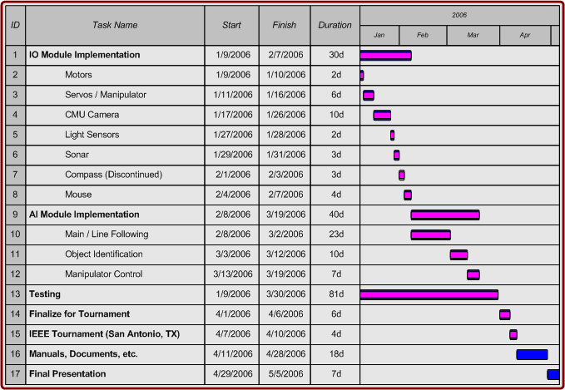Current Timeline

Since we have attended the competition, we are nearly finished with our project. No more work on the robot shall be required. As indicated on the timeline, all that is left is to take time writing any documents or manuals and to prepare for the final presentation.

Goals
The only goals left are to write documents and manuals for future teams or anyone else working with the robot and to prepare and give our final presentation.

